TÜV NORD Integra  Certification in agriculture and food  Statiestraat 164  B-2600 Berchem  Phone number : +32 3 287 37 60  Fax number : +32 3 287 37 61 |  | 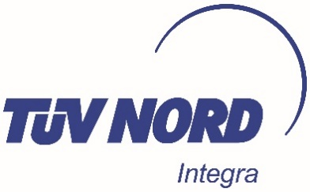

NOTICE OF ACTIVITY
for the usage of the Ecogarantie®-standard

- Company details
Company name
(as registered in the official business register of your country)

Corporate structure / legal entity

Address (as registered in the official business register of your country)

VAT number
Website

Legal representative
(as registered in the official business register of your country)
Phone number
E-mail address

Contact person
Phone number
E-mail address

2. Product information
Type of activities | ☐ Producer  ☐ Processor / Repacker  ☐ Distributor / Importer  ☐ pre-packaged products  ☐ bulk products  ☐ Sales outlet
Do you carry out the activities for a third party (as a contractor)? | ☐ Yes  ☐ No
Category of products on which you want to use the logo | ☐ Cosmetics  ☐ Washing and cleaning products  ☐ Air fresheners  ☐ Sea salt  ☐ Candles
Location(s) where the activities are carried out (address)

☐ The company commits to perform operations in accordance with the Ecogarantie® standard.

☐ The company declares that it has entrusted the inspection to the accredited inspection body TÜV NORD Integra.

Drawn up in | Date
Name of legal representative | Signature  Certified true and correct

